EQIVALENCE PARTION

CONSIDER THE DATA TO BE VALIDATED
1-500

RANGE OF VALUES TO BE TESTED
-100-0 -> -51
1-100 -> 98
101-200 -> 196
201-300 -> 254
301-400 -> 362
401-500 -> 412
500-600 -> 580

BOUNDARY VALUE ANALYIS

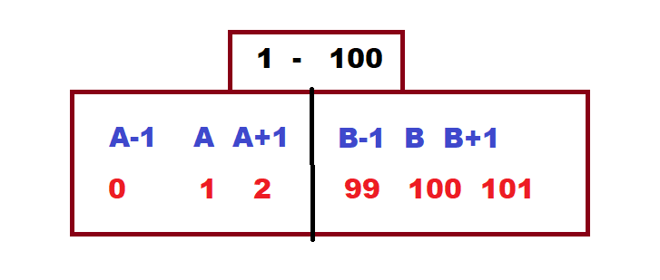

STATE TRANSITION

